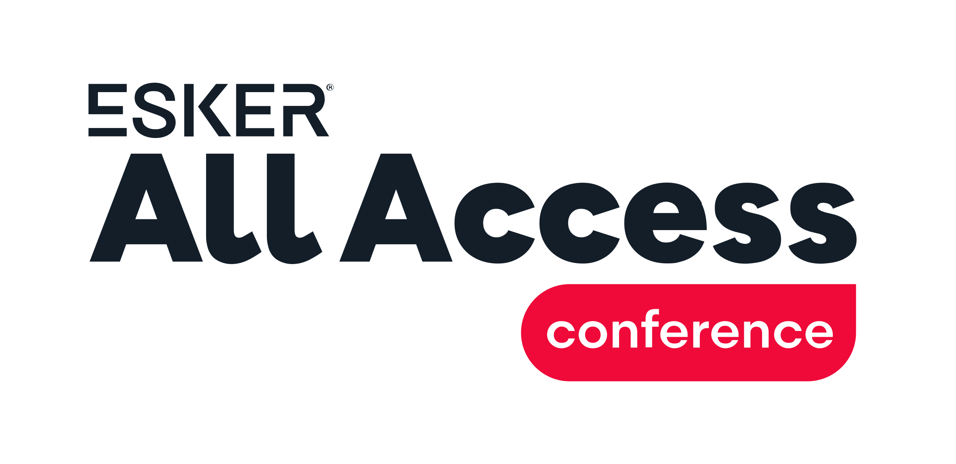

Dear {BOSS’S NAME},

I’m writing for your approval to attend the Esker All Access conference on September 9-10, 2026, at the Loews Chicago O’Hare Hotel in Rosemont, IL. With a focus on elevating AI strategies to support the modern Office of the CFO, there will be a lot of take-home strategies being shared that will help {DEPARTMENT NAME} be more effective as a department.

Specifically, I believe attending Esker All Access 2026 would help me and our team:
- Expand our use of Esker solution{s} to achieve greater ROI and KPIs such as:
  - {KPI 1 (e.g., Increased digital order/invoice percentage, etc.)}
  - {KPI 2 (e.g., Reduced DSO, billing costs, etc.)}
  - {KPI 3 (e.g., Support business growth without adding headcount, etc.)}
- Support the expanding AI automation initiatives within our department and across our business
- Learn about new product features we can take advantage of immediately

Esker All Access 2026 features expanded breakout sessions, super user training opportunities and even 1:1 consultations — along with several customer presentations and keynote speakers.

Here’s a breakdown of what it will approximately cost to attend:
- Conference registration fee: $899
- Hotel: {AMOUNT}
- Roundtrip airfare: {AMOUNT}
- Transportation: {AMOUNT}

Considering the reasonable cost and wide range of educational and networking opportunities offered, I’m confident Esker All Access 2026 will yield an impressive ROI for our company.

I appreciate your consideration of my request and look forward to your reply.

Thanks,

{YOUR NAME

